Department of Computer Science and Engineering
The University of Texas at Arlington
Sliding Profiler
Detailed Design Specification

Super Duper TxDOT Troopers

Team Members:
Tim Dockins
Robyn Johnson
Brandon Skinner
Late Updated: d MMMM yyyy 40010.8805555556 h:mm:ss am/pm
Copy Printed: d MMMM yyyy 39982.4569444444 h:mm:ss am/pm

Table of Contents
1 Introduction 1
1.1 Overview 1
1.2 Product Scope and Overview 1
1.3 Document Organization 1
1.4 Methodology 2
1.5 Definitions 2
2 Architectural Overview 3
2.1 Software Deployment 3
2.2 External Interface 3
2.3 Platform System 4
2.4 Hardware System 5
2.5 Software System 6
2.6 Architectural Composition / Deployment 6
3 Design Overview 7
3.1 Introduction 7
3.2 Physical Platform / Paver Mount 7
3.3 Hardware/Electronics Processor component 7
3.4 Programming Language selection 7
3.5 Embedded Device and the Client PC Application Connectivity 7
4 Platform Design 9
4.1 Introduction 9
4.2 Design Considerations 9
4.3 Sled Design 9
4.4 Hardware Mount Design 12
4.5 Distance Encoder Wheel Assembly 13
5 Hardware 14
5.1 Introduction 14
5.2 Design Considerations 14
5.3 Hardware Design 14
5.4 Printed Circuit Board Design 20
6 Software 21
6.1 Introduction 21
6.2 Embedded Software 21
6.3 Module Details 23
6.4 Client PC Software 34
7 Traceability Matrices 39
7.1 Hardware / Platform Traceability 39
7.2 Software Traceability 44
8 Quality Assurance 48
8.1 Design Completeness 48
8.2 Design Feasibility 48
Listing of Figures
Figure 1 - Existing Sliding Profiler 1
Figure 2 - Sliding Profiler Systems 3
Figure 3 - Inter-System Interfaces 3
Figure 4 - Platform subsystems 4
Figure 5 - Hardware Subsystems Dataflow 5
Figure 6 - Software Architecture 6
Figure 7 - Sled Framework Design 10
Figure 8 - Sled Surface Design - bottom 10
Figure 9 - Sled surface top 11
Figure 10 - Platform Side view showing Housing Mount placement 12
Figure 11 - Hardware Mount Plate - Top View 12
Figure 12 - Toggle-clamps 13
Figure 13 - Distance Encoder Wheel Assembly 13
Figure 14 – Power Subsystem Diagram 16
Figure 15 – Sensor Subsystem Diagram 17
Figure 16 – Display Subsystem Diagram 18
Figure 17 – Cooling Subsystem Diagram 19
Figure 18 – PCB Design for Daughterboard 20
Figure 19 - Modules deployed on the Embedded Device 23
Figure 20 - Major Profiler Functions 25
Figure 21 - Communications between threads 26
Figure 22 - Static Class Diagram for Client PC Application 34
Figure 23 - MDI Window Mockup 37

Introduction

Overview
This document specifies the detailed design for the Sliding Profiler. The general approach used in the architecture was an interrelated systems model defining the each system as a set of subsystems where each subsystem provides the functional relationships between the systems. The motivation here to enable an abstraction in the detailed design process between the systems so that changes in one system require little to no change in other systems.
Our design methodology is explained below but generally included prototyping, function-oriented and object-oriented design. One major element to this project is the profiling algorithm that is used to process the raw profile data into bump events. This element was provided by Dr. Roger Walker and is provided in this Detailed Design Specification document under Listing 2 - Profiler Function Pseudo-code.

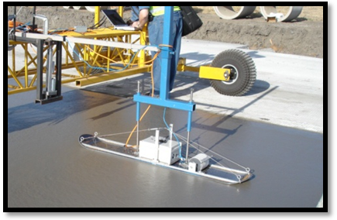
Product Scope and Overview
The Sliding Profiler is currently realized as a prototype used by TxDOT contractors. It is designed to slide behind a road paving machine to measure and indicate sharp bumps in the pavement that would cause poor ride quality.
Figure 1 - Existing Sliding Profiler
The scope of this effort is to replace and redesign the key components of this product. These components are as follows:
- Platform – Currently implemented as a snow ski
- Embedded Device – currently an embedded PC running Windows CE
- Client Software – Not implemented with the current prototype

Document Organization
The document is organized as follows:
Section 1 Introduction, Product Scope and Definitions
Provides an overview of the product, our design methodology and some of the key definitions for terms included in the document.
Section 2 Architectural Overview
The Architectural Overview provides a recap of the Architectural Design Specification. This is strictly to serve as a reminder of the relevant structures of the system.
Section 3 Platform System
Provides the detailed designs for the platform system.
Section 4 Hardware System
Provides the detailed designs for the hardware system.
Section 5 Software System
Provides the detailed designs for the software system.

Methodology
The design methodology used was a mixture of prototyping, system diagramming and object-oriented design. Several prototypes were made of the platform’s sled unit. The hardware PCB and various other elements were diagrammed, as shown in this document. Software was designed from a functional perspective, using the known tool chain.

Definitions
- Operational Data data indicating bump and/or exception events
- Raw Data sensor information received directly from the sensors
- Paver a machine used to mold cement into lane-width pavement
- TxDOT Texas Department of Transportation

Architectural Overview
The Sliding Profiler is decomposed into three distinct, but interrelated systems; platform, hardware and software. While each system can be described separately, they must rely on each other to perform the overall function of the device. This section describes the architectural makeup of the product with relation to those systems.
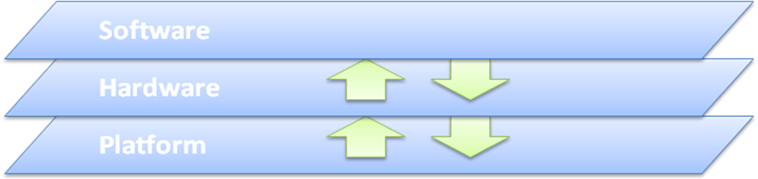
Figure 2 - Sliding Profiler Systems

Software Deployment
The Software system is deployed across two operating systems:
- A client PC
- An embedded device
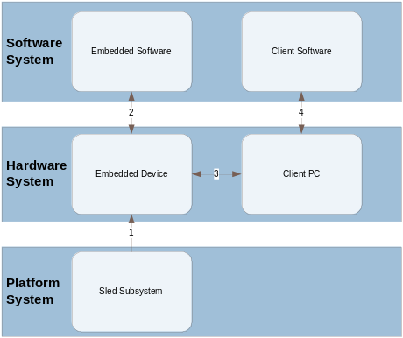Software subsystems may be discussed in terms of their deployment as client software and embedded software.

External Interface
The primary external interface to the product is through the Platform system. This is in terms of physical contact with the cement. This is translated through the Sled subsystem of the Platform to the sensor subsystems of the Hardware.

Figure 3 - Inter-System Interfaces

Platform System

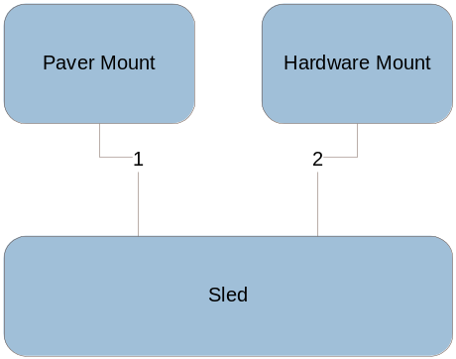Subsystems
The Platform system is comprised of three subsystems as follows:

- Paver Mount
- Hardware System Mount
- Sled

Figure 4 - Platform subsystems

Paver Mount
The paver mount is the mechanism by which the profiler will be physically attached to a standard road paver used by contractors. It aids in providing stability and ease of movement to the platform structure.

Hardware System Mount
The hardware system mount is the medium by which the electronics housing box will attach to the top side of the platform structure.

Sled
The sled portion of the profiler is the part of the product that glides across wet road surface. It provides a platform for which the profiler electronics and sensors can function and collect data.
Responsibilities:
- Translation of the inclination of the cement surface plane perpendicular to a vertical position
- Translation of the forward-progress of the plane in a direction that is parallel to that plane

Hardware System

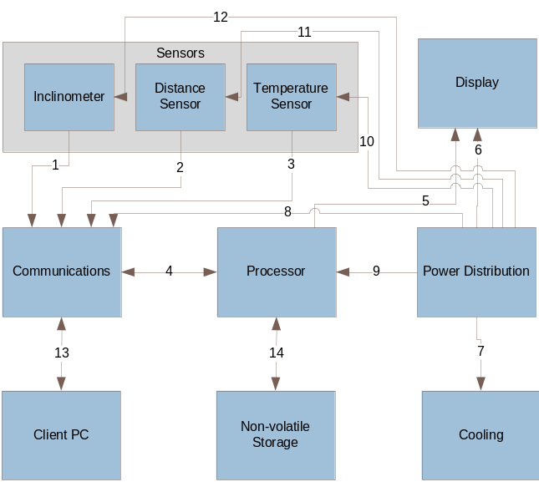Subsystems
The Hardware system is comprised of the following subsystems:

- Electronics Housing
- Sensors
- Display
- Communication
- Processor
- Storage
- Cooling
- Power Distribution
- Client PC

Figure 5 - Hardware Subsystems Dataflow

Software System

Architectural Composition / Deployment
The Software system architecture can be decomposed into Layers and Subsystems as shown below.

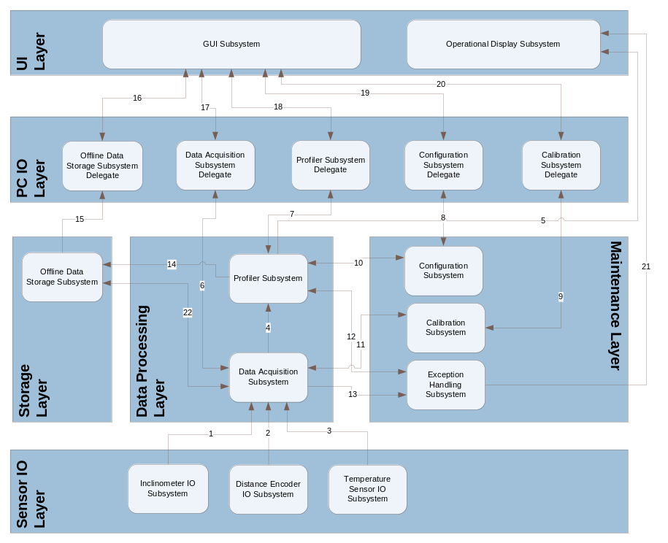
Figure 6 - Software Architecture

Design Overview

Introduction
The design of the Sliding Profiler encompasses physical, hardware and software components. Software components include executable code running on the device hardware as well as a client PC application. In general, the physical platform, hardware electronics and the embedded software are sufficient for the stand-alone operation of the device. In order to provide configuration, calibration and data retrieval capabilities, the client PC application is necessary.

Physical Platform / Paver Mount
The physical platform is composed of a sled, a hardware mount and a paver mount. For the sake of this project, SDTT will focus on the sled and hardware mount. Instead of re-creating a paver mount, the sled will provide the mounting brackets necessary to interface with the existing paver mount.

Hardware/Electronics Processor component
The team selected the TS-7250 Single-Board Computer incorporating an ARM9 processor with PC/104 expansion connectivity. The device provides 64 MB memory with USB access. It comes installed with an version of Linux geared to operate with the hardware components such as the Analog/Digital and Digital/Analog convertors.

Programming Language selection
The embedded software will be written in C or C++ depending on the available tool chain on the embedded system. The client PC application will be written in Java based on the team’s familiarity with that language.

Embedded Device and the Client PC Application Connectivity
There are three scenarios for connectivity between the embedded device and the client PC application. These circumstances, and the design consideration for them, are explained as follows:

General Connectivity
The Embedded Device has an 802.11g wireless network interface. This interface will be placed into Ad-hoc mode on a given subnet and broadcasting an SSID. To interface with the device, client PC’s will join that network in an ad-hoc manner. All communications will occur in this manner. At this point, no consideration is given to security, though that may be a future upgrade.

Commands from PC to Embedded Device
The Embedded Device will run an instance of Apache web server. CGI scripts will provide functional response to commands coming from the client PC application for calibration, configuration and data retrieval. HTTP will be the protocol of choice. Responses to the commands will be part of the HTTP response.

Real-time Data Retrieval
When operating, the device will provide real-time data by using the subnet broadcast address on a port specified during project implementation. The client PC application will listen for UDP message from that device.

Platform Design

Introduction
The Platform provides the physical structure by which this product executes its purpose. The design was derived from two sources: the original pilot system and discussions with the sponsor regarding good design guidelines. SDTT executed a prototyping design strategy. Simple plans, shown in this section, were created and developed into a prototype using scrap materials. The team sponsor provided feedback on the prototype and changes were made accordingly.
The design of the platform, originally composed of three elements (i.e. sled, hardware mount, and paver mount), encompasses the sled and the hardware mount. The team has decided to work with the existing paver mount system. Therefore, we only need to be concerned with the interface between the sled and the paver mount.

Design Considerations
The following is a list of considerations in the design:
- Surface area is important in distributing the weight of the platform over the surface of the wet cement. Not enough surface area and the weight becomes a major factor. In general, the sled should leave as little as an impression as possible.
- Weight is a major factor in the design of the platform. While surface area may help distribute it, keeping weight as minimal as possible is a concern.
- Durability is also a concern. While environmental impacts during operation may be inconsequential, the platform needs to withstand rough treatment between uses.

Sled Design
The Sled is a wooden frame shaped with a slight curve on the forward-moving edge. The lower surface is closed with a sheet of wood and further reinforced by galvanized sheet metal. The upper surface is also closed with a sheet of wood. Joints are fastened by 1 5/8” composite decking screws with a counter-sink head.

Sled Framework Overview
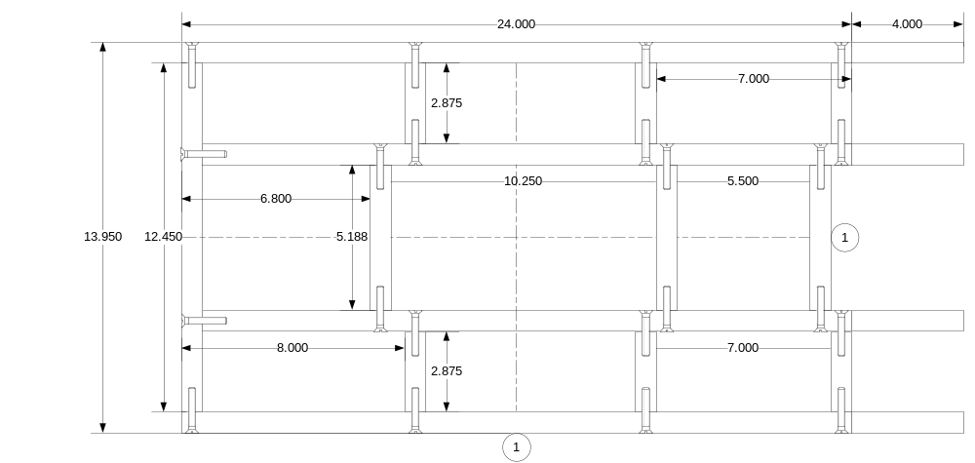
Figure 7 - Sled Framework Design

Sled Surface Design
The bottom, sliding surface of the sled is composed of two layers. The first layer is a wood paneling and is attached to the frame by a set of decking screws. The second, outer layer is a galvanized steel sheet that will be attached to the first layer by liquid nail adhesive.
Further, there is an opening towards the rear for the distance sensor wheel of the hardware.
The following figure indicates the layout for this surface:
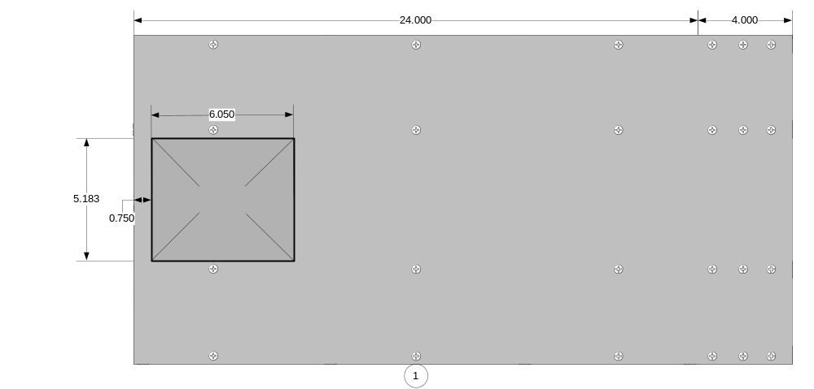
Figure 8 - Sled Surface Design - bottom
The top surface of the sled will also be covered by a thin, siding material. There will be openings for the distance sensor wheel and its belt assembly. These are indicated in the figure below:
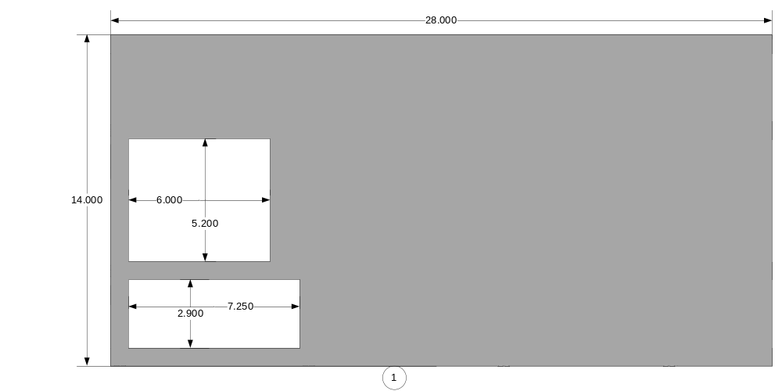
Figure 9 - Sled surface top

Sled Materials
Thus, the components of the sled frame are as follows:

No. | Description | Quantity
1 | Rib (.75” x 2” x 28”) with 24” flat-bottom and a curved forward edge. | 4
2 | Mid-frame cross-piece (.75” x 2” x 5.188”) | 3
3 | Side-frame cross-piece (.75” x 2” x 2.875”) | 6
4 | Cross-frame tail-piece (.75” x 2” x 12.450”) | 1
5 | Under-frame wood surface (13.95” x 28”) | 2
6 | Galvanized sheet metal surface (13.95” x 28”) | 1
7 | Composite Deck Screws (#8 – 1 5/8”) | 40 - 50
Table 1 - Materials List for Sled

Hardware Mount Design
The Hardware Mount fastens the Hardware housing to the sled. It is composed of an aluminum plate and two toggle clamps. The aluminum plate will be bolted to the Hardware housing box. The assemblage may then be clamped to the sled. These are aligned with three pegs, one at three different corners of the plate.

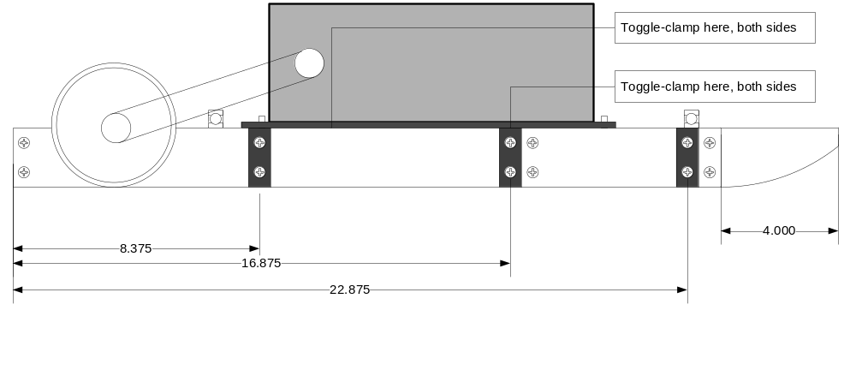
Figure 10 - Platform Side view showing Housing Mount placement

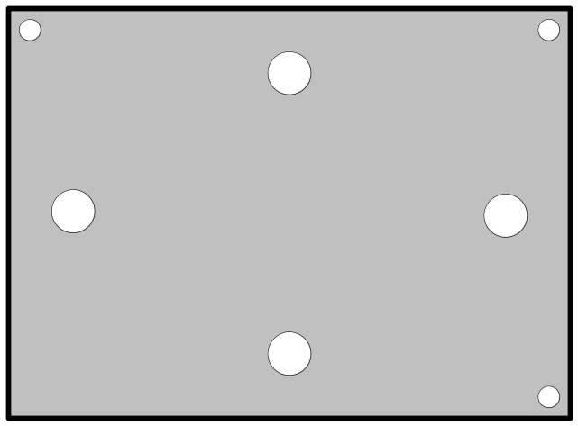
Figure 11 - Hardware Mount Plate - Top View

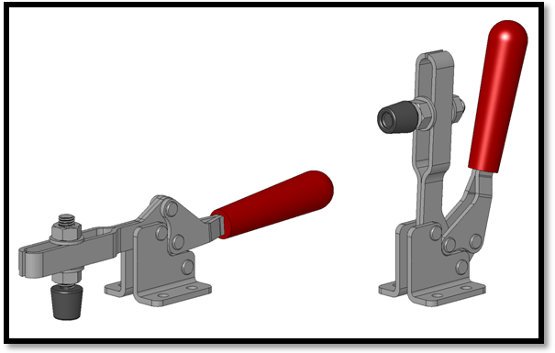
Figure 12 - Toggle-clamps

Distance Encoder Wheel Assembly

The Distance Encoder Wheel Assembly provides a translation from the surface of the concrete to the Distance Encoder. The entire assembly consists of the two shafts, one attached to the distance encoder and one attached to a wheel assembly as an axle. They are connected by a rubber gear-belt using a gear-belt pulley on each shaft. The wheel assembly consists of a plastic wheel attached to the axle by lug nuts, an expanding foam pad and an outer “tire” made from PVC. This arrangement is illustrated by the following figure:

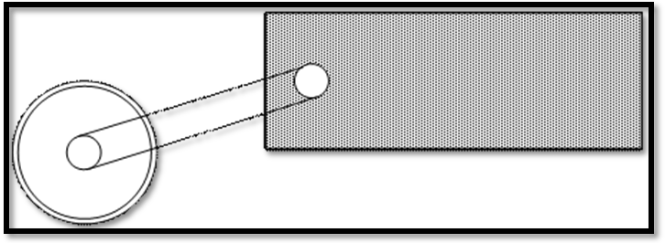
Figure 13 - Distance Encoder Wheel Assembly

Hardware

Introduction
The Hardware system describes the physical electronic devices as well as the supporting circuitry to allow them to function. It also describes the system for with the embedded software (described later) is stored and run on. It is responsible for providing all communication connections between devices as well as necessary power and ground connections for every device on board.

Design Considerations
The following is a list of considerations in the design:
- There will be a +12v DC source provided from the job site.
- The voltage source will provide sufficient current to run the device.
- The TS7250 Single Board Computer requires a voltage source of 5 volts with at least 1 amp of current.
- The electronics being designed to support the system should be neat and fit inside the electronics housing.
- The electronics inside the housing should have a high heat tolerance so ensure continued operation with an exhaust fan mounted to the housing.

Hardware Design
The hardware is a series of circuits that are dependent upon each other to provide their respective resources to the system. The Hardware system is designed in such a way that each subsystem is designed independently but when joined together, they provide support for the Software system that will be running on them. It is important to note that all components not implemented on the printed circuit board (PCB) will be connected to the PCB via screw terminals designated on the schematics as J#.

Electronics Housing
The electronics housing that has been selected is a weather proof plastic box that will be mounted to the plate in Figure 11. It measures 7.5” x 14” x 4” excluding the lid. We have selected this box due to its popular use by the sponsor.

TS-7250 Single Board Computer (SBC)
The TS-7250 has been selected to be the heart of our system. It will provide all our computations, storage, and communications for our system. It was selected primarily because of its large memory size, accessories, and small version of Linux. It will provide us with our Non-Volatile storage subsystem, Communication to the sensors as well as to the Client, and the Processor subsystem.

Non-Volatile Storage Subsystem
This subsystem will consist of a USB drive connected to the SBC. It will be formatted to the ext2 file system so the Linux operating system can access it.

Communication Subsystem
This subsystem will consist of an Analog-to-Digital Converter on the SBC that will provide necessary communications from the Sensors to the Processor. It will be responsible for converting the voltage signals into a digital signal so that the software can use the digital signal to convert it to their respective measurement.
This subsystem will also contain an 802.11g Wireless USB Ethernet adapter that will provide us with a medium to communicate directly with the client. It will be configured as an Ad-Hoc Ethernet device and will be used to broadcast UDP packets to the client during run-time mode. It will be connected to the client using TCP/IP for calibration and configuration modes.

Processor Subsystem
The processor on the TS-7250 is a Cirrus Logic E9301. This processor is designed around the ARM9 architecture and it operates natively at 166MHz but has been configured on the TS-7250 to operate at 200MHz.

Power Subsystem
The power management subsystem is designed to take in a 12v DC source and convert that voltage to the voltages needed by all Subsystems in order to operate efficiently. The necessary voltages are +5vdc, +12vdc, +15vdc, and -15vdc. This is accomplished with voltage regulators and a DC-DC converter. All power will be controlled by a master switch mounted on the housing.
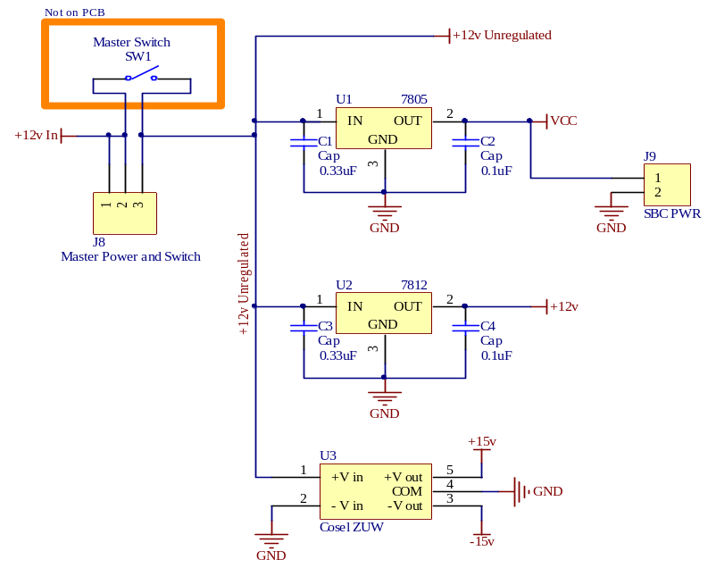
Figure 14 – Power Subsystem Diagram

Sensor Subsystem
The sensor subsystem consists of three sensors. A temperature sensor (LM34CZ), an Accu-Coder 15-T/H series distance encoder, and a Columbia Research Labs ±45º SI-701BHP inclinometer.

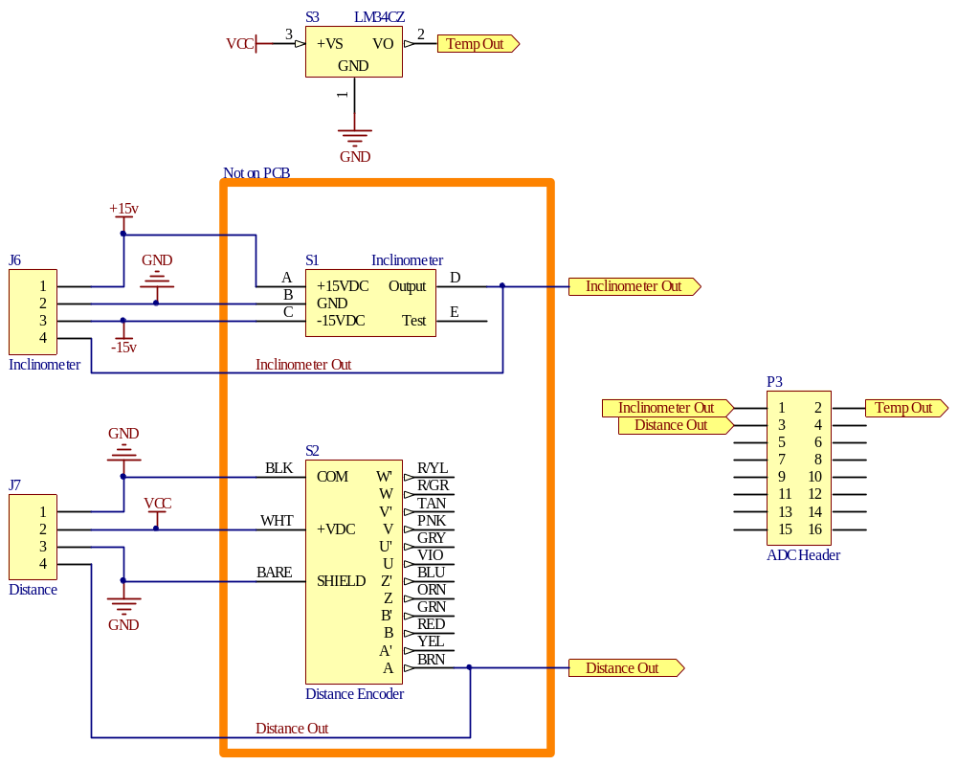
Figure 15 – Sensor Subsystem Diagram

Display Subsystem
The display subsystem is a series three LED’s and one bright beacon light used to indicate various conditions to the user. The design of this subsystem is that the LED’s connect to the Digital IO port (DIO) on the SBC. They are directly controlled by the processor and supporting software. The beacon light requires a higher current than the SBC can supply so there will be a relay used that is controlled by the SBC to flash the beacon light.

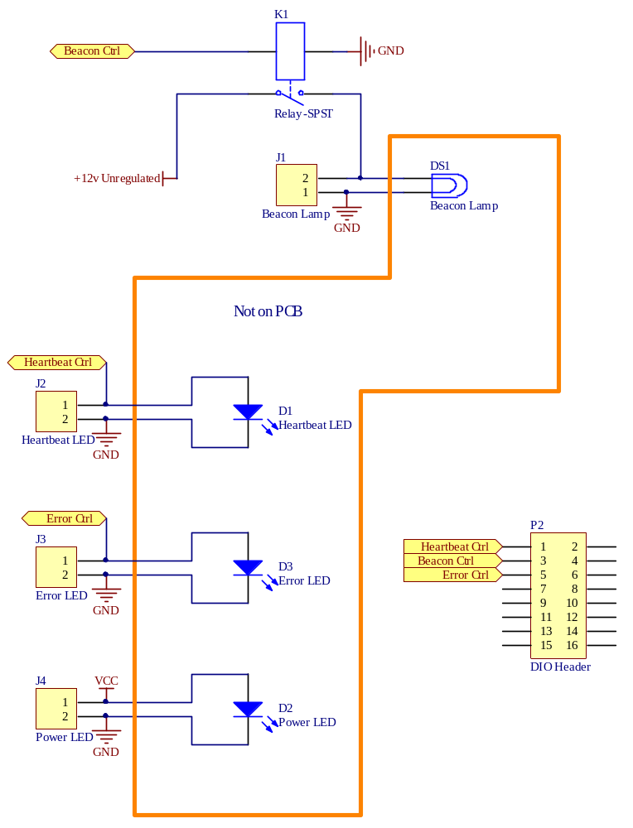
Figure 16 – Display Subsystem Diagram

Cooling Subsystem
The cooling subsystem is a simple yet very important subsystem. It consists of a fan mounted to the side of the electronics housing hooked up to the 12v unregulated power source. For selecting the fan, three factors were considered: size, noise decibel (dB) levels, and flow rate (CFM). Due to the height limitations of the housing, we decided to go with a 60mm fan. For the other two considerations, we realized that they are linearly proportional to each other. The higher the flow rate, the noisier the fan is. Although it’s not entirely necessary to have a quiet fan, we had to consider that we would be testing this around school and as a result we selected a fan that is in the middle of the noise spectrum. This led us to our decision of a fan that flows 21.5 CFM and has a noise level of around 30 dB. The fan will be connected as an exhaust fan and will have a screen to protect it from possible debris.

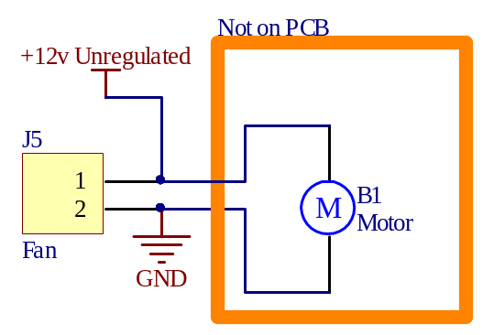
Figure 17 – Cooling Subsystem Diagram

Printed Circuit Board Design
The printed circuit board will have include all the circuitry of the schematics above that is not explicitly stated as not included on the PCB. It has been designed to act as a daughterboard to the TS-7250 without removing the flexibility of the PC/104 bus. This is accomplished by including a stack-through connector for the PC/104 so additional accessory boards could be added as necessary at a later date. This design has also been carefully drawn out to eliminate the need to use cables for the header extensions.

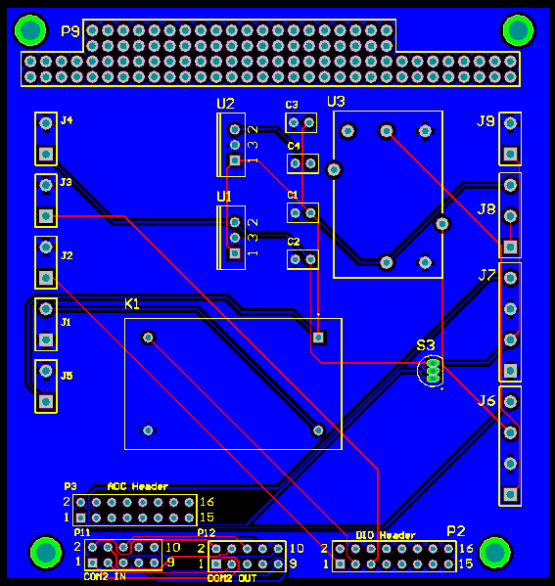
Figure 18 – PCB Design for Daughterboard
Figure 18 is showing the preliminary design of the PCB daughterboard for the hardware system. This is subject to change as the testing and implementation process continues.

Software

Introduction
Software for this project spans two systems and will be deployed across an embedded device and a client PC. This section will describe each deployment in detail and detail the communications between both.
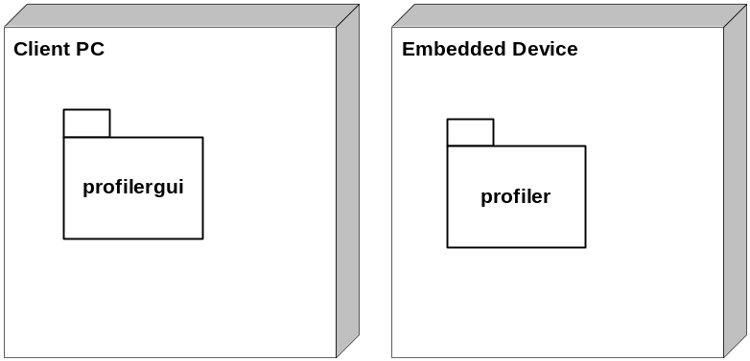

Embedded Software

Functional Modules
The Embedded Software, deployed on the embedded device, is composed of the following functional modules:

Module | Description
TS-Linux | The operating system providing access to the hardware layer , software loading, memory management, etc.
Apache Web Server | Provides HTTP access to the profiler
Initialization Script | The initialization script is the operating system initialization scripts that starts all the system level components (i.e. networking, file systems, apache web server, etc.). This script will be responsible for starting the profiler module.
Profiler | This is the core module for this application. It provides the data acquisition services, analyzes the data and generates events based on that information.
Configuration Script | A CGI script available through HTTP via the Apache web server. This script is responsible for accepting any configuration information from the client PC and storing it in the appropriate place for the Profiler module to use.
Calibration Script | A CGI script available as above. It is responsible for accepting a calibration command from the client PC application and storing the necessary calibration information in an appropriate place for the Profiler module to use.
ProfileDataRetrieval Script | A CGI script as above. It is responsible for reading the stored profiler event data and returning it to the client PC.
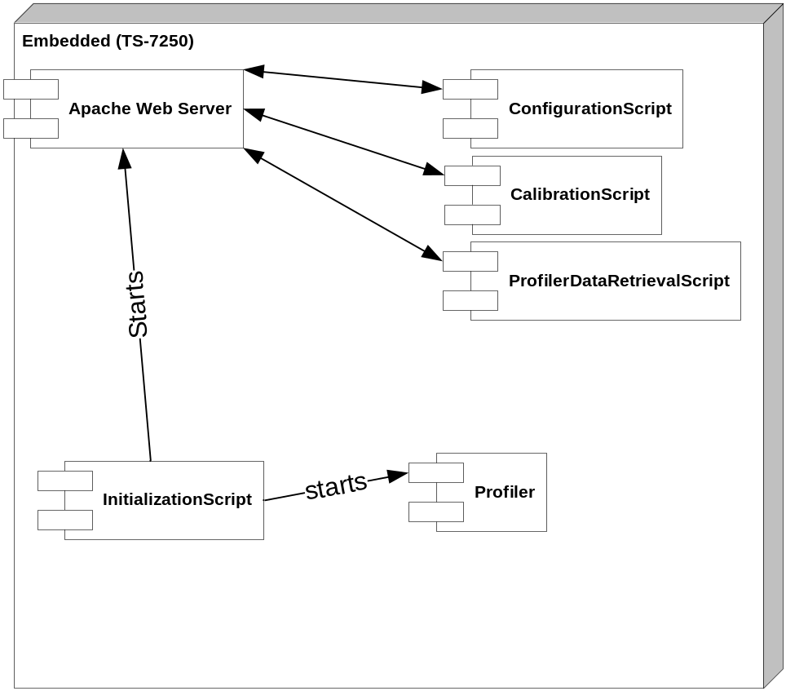
Figure 19 - Modules deployed on the Embedded Device

Module Details
The details of TS-Linux and the Apache web server may be found with their respective documentation. Modifications to the Apache web server setup will occur during implementation according to its documentation on setting up CGI scripts.
Our modification to the initialization script is simply adding the profiler module as a daemon service that should run as soon as the operating system starts. The focus then is on remaining modules.

Profiler Module
The profiler module will be written in the C programming language and compiled using the tool-chain provided with the TS-7250 device. The module is similar to that provided by the Sponsor as part of their original prototype. It is comprised of several structures and functions as follows:

Structures

Structure | Description
sp_params | Holds the system parameters.  typedef struct sp_params{  int threshold;  int cpf;  int bump_check;  float inclparam1;  float inclparam2;  int raw_length;  float bias_length;  int shutdown_temp;  } * sp_params_t;
sp_flags | Holds general flags for program control  typedef struct sp_flags {  unsigned int start_system:1;  unsigned int pause_system:1;  unsigned int shutdown_system:1;  unsigned int analysis_started:1;  unsigned int restart:1;  unsigned int transmit_data:1;  } * sp_flags_t;
sp_algorithm | Holds run-time data for calculations to detect bumps.  typedef struct sp_algorithm {  DFLOAT *profile_buffer;  // profilerBuffer  DFLOAT *running_avg_buffer;  // n_profileBuffer  int buffer_idx; // profileBufferWriteIndex;  INT buffer_start; // raw_start  INT ref_idx; // cur_pp  DWORD total_transfers;  DWORD sample_idx;  // read_pointer;  DFLOAT profile;  // prevReading  LONG distance_counter;  // dist_cntr;  LONG bump_delay_check;  /* bump checks are delayed until (bump_delay_check < bump_check) */  } * sp_algorithm_t;
Other structures may be created as needed.

Functions
The following functions represent the main functionality of the module. Other functions may be created as necessary as needed (i.e. helpers, initialization, etc.).
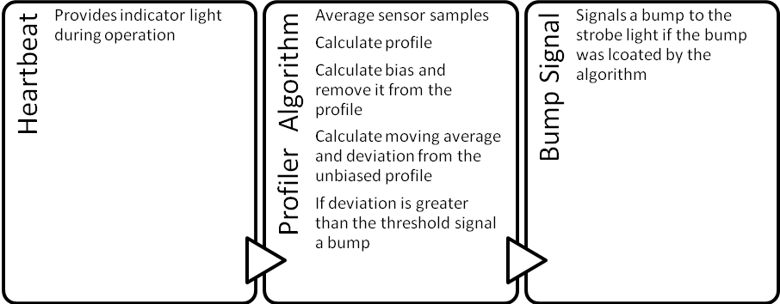
Figure 20 - Major Profiler Functions

Concurrency and Communications
These three functions will execute at the same time as three separate threads. Events will be used to communicate between threads.
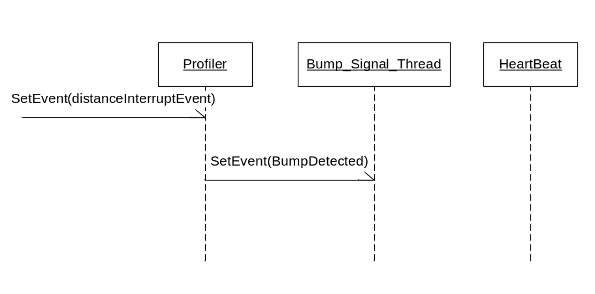
Figure 21 - Communications between threads
Heartbeat function
The heartbeat function is responsible for flipping the heartbeat DIO line every so often to indicate that the system is working.
Parameter(s):
- memory address for digital out
- length of time to keep signal high
- length of time between heartbeats
Side Effect(s): Modifications to the value in given memory address
Bump Signal function
The Bump Signal function is responsible for flipping the bump strobe DIO line when a bump has been indicated by a bump event. In general, the bump signal will execute a continuous loop until a bump event occurs.
Parameter(s):
- memory address for digital out
- length of time to keep signal high
- length of time between heartbeats
Side Effect(s): Modifications to the value in given memory address

Pseudo-code:
VOID bump_signal_thread(LPVOID params)
{
sp_struct_t profiler = (sp_struct_t)params;
sp_daq_t daq = &profiler->daq;

while(1) {
if(WaitForSingleObject(hEvtFoundBump, INFINITE) != WAIT_OBJECT_0) {
printf("\nWaitForSigleObject(hEvtFoundBump) failed!!!");
continue;
}

dscDIOOutputBit(daq->board, DIO_PORTB, DIO_SOLENOID, LOW);
dscDIOOutputBit(daq->board, DIO_PORTB, DIO_STROBE, LOW);
Sleep(BUMP_SIGNAL_DUTY);
dscDIOOutputBit(daq->board, DIO_PORTB, DIO_STROBE, HIGH);
dscDIOOutputBit(daq->board, DIO_PORTB, DIO_SOLENOID, HIGH);
}
}
Listing 1 - Bump Signal Pseudo-code
Profiler Function
The profiler function has the following responsibilities:
- Average sensor samples
- Calculate profile
- Calculate bias and remove it from the profile
- Calculate moving average and deviation from the unbiased profile
- If deviation is greater than the threshold signal a bump by raising the event
- Save the event data to a data file
- Broadcast the event data over the Ad-hoc network’s broadcast address
The following pages provide a code listing for the existing profiler function.
Pseudo-code:
The following is a listing of the original function. In general, the profiler function will operate on the same principles. The implementation details may be different because of the platform change.

VOID distIntBh(LPVOID parameters)
{
sp_struct_t profiler = (sp_struct_t)parameters;
sp_flags_t flags = &profiler->flags;
sp_comm_t comm = &profiler->comm;
sp_algorithm_t algo = &profiler->algorithm;
sp_params_t params = &profiler->params;
sp_daq_t daq = &profiler->daq;
INT bump_check;
INT raw_length;
INT bias_length;
DFLOAT bias = 0; // calculated bias
DFLOAT ravg = 0; // calculated running average
INT i, j, k;
DWORD transfer_difference;
SDWORD num_samples_read; //number of samples read in this interrupt occurrence
SDWORD samples[DAQ_NUM_CHANNELS];
DFLOAT voltage[DAQ_NUM_CHANNELS];
char Buffer[100];
DFLOAT f_gyro, gyro_voltage;
DFLOAT temperature; // temperature in the sliding profiler box
DFLOAT deviation; // running difference
char *token;
INT size;

ERRPARAMS err = daq->error_params;

while(TRUE) {
if(WaitForSingleObject(hEvtDoDistIntBh, INFINITE) != WAIT_OBJECT_0)
printf("\nWaiting on hEvtDoDistBh failed!!!");

if(dscGetStatus(daq->board, &daq->dscs)) {
printf("%s:%s: dscGetStatus() could not get DSCUD status!!!",__FILE__,__LINE__);
continue;
}

memset(samples, 0, sizeof(samples));

if (transfer_difference == 0)
continue;

if (transfer_difference > DAQ_NUM_CONVERSIONS)
transfer_difference = DAQ_NUM_CONVERSIONS;

for(i=0; i<transfer_difference/DAQ_NUM_CHANNELS;i++) {
for(j=0; j<DAQ_NUM_CHANNELS; j++) {
samples[j] += daq->sample_buffer[algo->sample_idx];
algo->sample_idx = (algo->sample_idx+1)%DAQ_NUM_CONVERSIONS;
}
}

num_samples_read = transfer_difference / DAQ_NUM_CHANNELS;
algo->total_transfers = daq->dscs.total_transfers;

for(i=0; i<DAQ_NUM_CHANNELS; i++) {
samples[i] = samples[i] / num_samples_read;
if( dscADCodeToVoltage(daq->board, daq->dscadsettings, (DSCSAMPLE)samples[i], &voltage[i]) != DE_NONE ) {
dscGetLastError(&err);
fprintf( stderr, "dscADCodeToVoltage error: %s %s\n",
dscGetErrorString(err.ErrCode), err.errstring );
flags->shutdown_system = TRUE;
return;
}
}

if (!flags->start_system || flags->pause_system)
continue;

bump_check = params->bump_check*params->cpf;
raw_length = params->raw_length*params->cpf;
bias_length = (INT)(1.0*params->bias_length*params->cpf);
algo->distance_counter++;
bias = ravg = 0;

temperature = cel2fahr(voltage[0]*100);
f_gyro = gyro_voltage = voltage[1];

if(temperature > params->shutdown_temp) {
flags->shutdown_system = TRUE;
continue;
}

// Calculate the current profile
f_gyro = (f_gyro - params->inclparam1)/(1.414 * params->inclparam2);
algo->profile = algo->profile + f_gyro * 12000/params->cpf;

profileBuffer[algo->buffer_idx] = algo->profile;
deviation = 0;

if (algo->distance_counter < bias_length) {
n_profileBuffer[algo->buffer_idx] = algo->profile;
algo->buffer_idx = (algo->buffer_idx+1) % bias_length;
goto Send;
}

if(!flags->analysis_started) {
flags->analysis_started = TRUE;
for(i=0; i<bias_length; i++)
bias += profileBuffer[i];
} else {
bias =(bias + profileBuffer[algo->buffer_idx] - profileBuffer[(algo->buffer_idx+1) % bias_length]);
}

bias /= bias_length;
n_profileBuffer[algo->buffer_idx] = algo->profile - bias;
algo->buffer_idx = (algo->buffer_idx+1) % bias_length;

if(algo->distance_counter < bias_length + raw_length)
goto Send;

////////////////////////////////////////////////////////////////////////////
// calculate moving average
////////////////////////////////////////////////////////////////////////////
// I should really optimize this - tsb
for(k=0, ravg=0, j=algo->buffer_start; k<raw_length; k++) {
ravg += n_profileBuffer[j];
j = (j+1) % bias_length;
}

algo->buffer_start = (algo->buffer_start+1) % bias_length;
algo->ref_idx = (algo->ref_idx + 1) % bias_length;
ravg /= raw_length;
deviation = n_profileBuffer[algo->ref_idx] - ravg;

if(++algo->bump_delay_check < bump_check)
goto Send;

if (deviation >= params->threshold || -deviation >= params->threshold) {
SetEvent(hEvtFoundBump);
algo->bump_delay_check = 0;
}

Send:
if(flags->transmit_data) {
sprintf(Buffer, "%d %f %f %f %f %f %f;",
algo->distance_counter,
gyro_voltage,
algo->profile,
(algo->profile-bias),
ravg,
// Running average and deviation are always calculated
// with delay of 1/2 of raw_length before current profile point
deviation,
temperature
);
token = strstr(Buffer,";");
size = sizeof(Buffer);

if(token != NULL)
size = token - Buffer;

send(comm->datasock, Buffer, size, 0);
}
}
}
Listing 2 - Profiler Function Pseudo-code

ConfigurationScript module
The configuration script module is an executable implementing the Common Gateway Interface and called by HTTP request to the Apache server. Using CGIC, an ANSI C library for the creation of CGI-based applications, the ConfigurationScript has the following responsibilities:
- accept configuration parameters as HTTP POST form data
- save the configuration parameters in an initialization file
- return an acknowledgement
Parameter(s):
- window size

CalibrationScript module
The calibration script module is also an executable implementing the CGI interface and called by HTTP request. It has the following responsibilities:
- Accept calibration command (i.e. “inclinometer” or “distance”)
  - If distance, also receives calibration distance
- Sample the appropriate sensor
  - Inclinometer
    - Save the difference between current voltage and 0 as a parameter in an initialization file.
  - Distance Encoder
    - Save the number of pulses for the given distance as a parameter in an initialization file.
Parameter(s):
- Sensor to calibrate (inclinometer or distance)
- If distance sensor, calibration distance to be used

DataRetrievalScript module
As above, the DataRetrievalScript module is an executable implementing the CGI interface through the CGIC library. It has the following responsibilities:
- Accept retrieval command
- Respond by sending current data file

Client PC Software
The Client PC Software will be a desktop application. It generally follows the Model-View-Controller design pattern. This section describes the Model classes in detail.
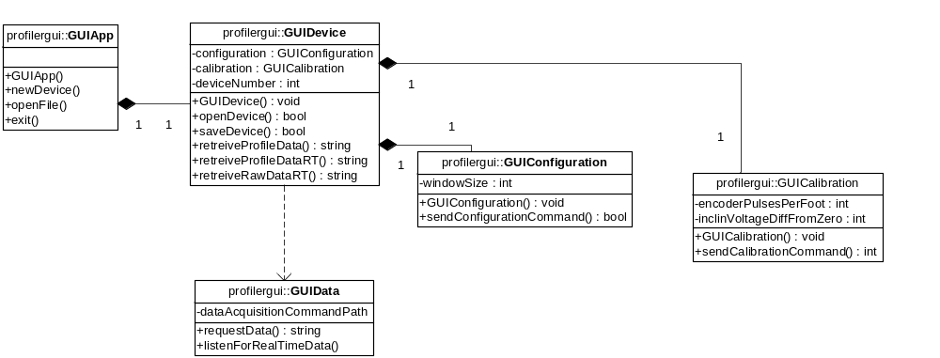
Figure 22 - Static Class Diagram for Client PC Application

Client PC Application classes
In general, there is one-to-one correspondence between the model classes and a form class implementing the view component of the MVC pattern.

GUIApp
The GUIApp is responsible for providing methods for instantiating devices or opening data files from the operating system.
Attribute(s): none
Method(s):
Method | Description | Return Value
GUIApp() | Default Constructor | void
NewDevice() | Factory method that instantiates and returns a GUIDevice object | GUIDevice
NewDevice(integer) | Factory method that instantiates and returns a GUIDevice object with data appropriately read from a file | GUIDevice

GUIDevice
The GUIDevice is responsible for models a Profiler Device.
Attribute(s):
Attribute | Description | Type
configuration | Holds reference to a configuration object | GUIConfiguration
calibration | Holds reference to a calibration object | GUICalibration
deviceNumber | Holds the device number | Integer
dataBuffer | Holds data from the Device | StringBuffer

Method(s):
Method | Description | Return Value
GUIDevice() | Default Constructor | Void
GUIDevice(integer) | Overloaded Constructor  Calls OpenDevice(integer) to initialize data from a file. | Void
OpenDevice(integer) | Initializes attributes in this object with data from a file | Boolean
SaveDevice() | Saves data from this object to a text file | Boolean
RetrieveProfileData() | Sends HTTP command to embedded device and puts results in dataBuffer | Boolean

GUIConfiguration
The GUIConfiguration class models the configuration elements of a sliding profiler. It is included a separate element for later expansion.
Attribute(s):
Attribute | Description | Type
windowSize | Describes the sliding distance window size | integer

Method(s):
Method | Description | Return Value
GUIConfiguration() | Default Constructor | Void
sendConfigurationCommand() | Sends a configuration command to the embedded device | Boolean

GUICalibration
The GUICalibration class models the calibration elements of a sliding profiler. It is included a separate element for later expansion.
Attribute(s):
Attribute | Description | Type
encoderPulsesPerFoot | The number of distance encoder pulses per foot of lateral travel | integer
inclinVoltageDiffFromZero | The difference of the voltage from 0 V | float

Method(s):
Method | Description | Return Value
GUICalibration() | DefaultConstructor | Void
sendCalibrationCommand(Enum SensorType, Integer <value>) | Sends Calibration command to embedded device as HTTP post and saves responses appropriately in class attributes. | Boolean

GUIData
The GUIData is an abstract class that cannot be instantiated, but it’s methods are called from a Class reference.
Attribute(s):
Attribute | Description | Type
dataAcquisitionCommandPath | The URL path to the DataRetrievalScript module | Integer

Method(s):
Method | Description | Return Value
requestData() | Sends data request to the embedded device as an HTTP GET and provides a StringBuffer | StringBuffer
listenForRealTimeData() | Begins listening on the appropriate port for data coming from the given device. Returns data as a StringBuffer reference | StringBuffer

Forms
The following mock-ups indicate forms that will be used:

GUIAppForm
The system will implement a Multiple Document Interface (MDI) application window as follows:
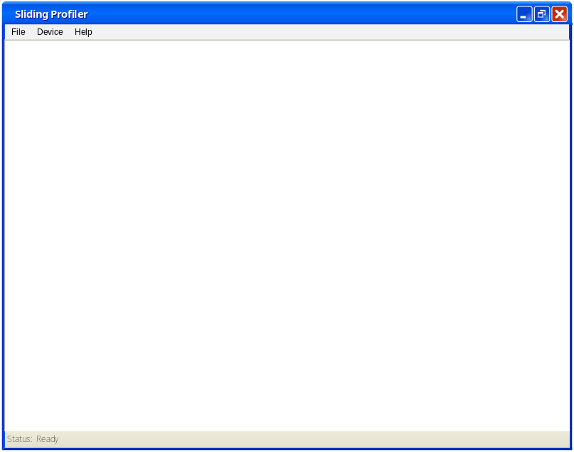
Figure 23 - MDI Window Mockup
The menu structure for this form will be:
- File
  - Exit
- Device
  - New Device – opens a new GUIDeviceForm, instantiates a new GUIDevice object
  - Open Device – opens a message box asking for a device ID. Then, instantiates a new GUIDevice based on that ID, and opens the GUIDeviceForm with the data populated
- Help
  - About – opens a message box with software version number

GUIDeviceForm
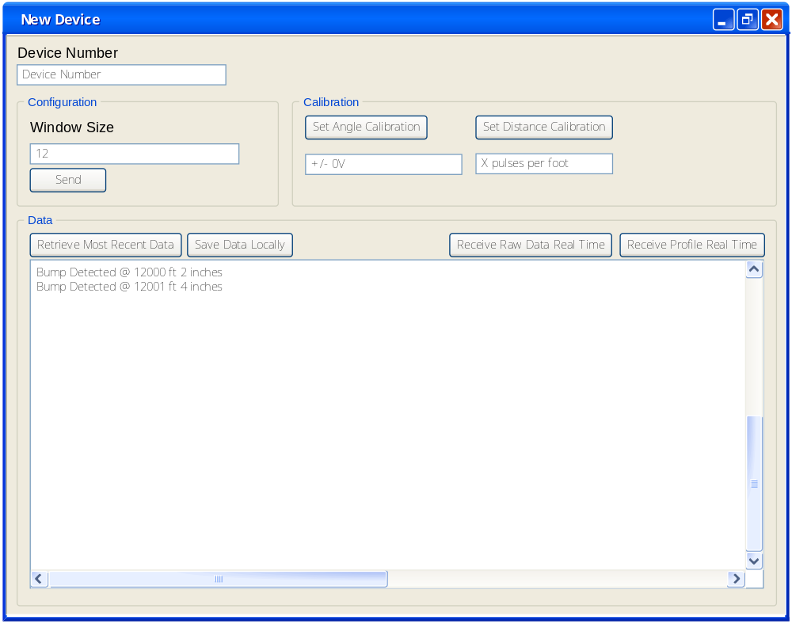
The GUIDeviceForm has three panels (i.e. Configuration, Calibration and Data) which are described as follows:
The Configuration panel contains the current window size and a send command button. The send command button will activate the GUIConfiguration.sendConfigurationCommand() method.
The Calibration panel contains the current data and two set buttons which also activate the appropriate GUICalibration.sendCalibrationCommand() method.
The Data panel has several buttons and a text field. The buttons are described as follows:
Retrieve Most Recent Data – calls the requestData method and places the data into the text area.
Save Data Local – takes anything in the text area and saves it to a text file. The user is prompted for a filename.
Receive Profile Real Time – calls the listenForRealTimeData() method and places the returned data in the text area.

Traceability Matrices

Hardware / Platform Traceability

Requirement | Platform | Sled | Hardware Mount | Paver Mount | Hardware | Electronics Housing | TS-7250 | USB Drive | WiFi 802.11g USB Dongle | A/D Converter | Power Distribution Module | Temperature Sensor | Accu-Coder Distance Encoder | CRLabs Inclinometer | Display / LED | Display / Beacon Light | Cooling Fan | Client PC
The Product shall visually indicate bumps using a beacon light. |  | x | x | x |  | x | x |  |  | x | x |  | x | x |  | x
The Product shall come with a storage solution.
The Electronics shall be detachable from the Platform. |  |  | x |  |  | x
The Product shall be able to operate in a stand-alone mode. |  | x | x | x |  | x | x | x |  | x | x |  | x | x | x | x | x
The Platform shall attach to a road paver. |  | x |  | x
The Platform shall be easy to clean. |  | x | x | x
The Device shall detect bumps in concrete pavement when its platform is pulled across the surface. |  | x | x | x |  | x | x |  |  | x | x |  | x | x |  | x
The Device shall be able to measure the travel distance of the platform. |  | x | x | x |  | x | x |  |  | x | x
The Device shall be able to measure the inclination of the platform from a calibration point. |  | x | x | x |  | x | x |  |  | x |  |  | x
The Device shall be able to measure the internal temperature of the electronics housing. |  |  |  |  |  |  | x |  |  | x | x | x
The Device shall visually indicate when it is operating. |  |  |  |  |  | x | x |  |  |  | x |  |  |  | x
The Device shall visually indicate error conditions. |  |  |  |  |  |  | x |  |  |  | x |  |  |  | x
The Device shall generate operational data from the raw data of the sensors. |  |  |  |  |  |  | x |  |  | x | x |  | x | x
The Device shall use an embedded microcontroller. |  |  |  |  |  |  | x |  |  |  | x
Configuration processes shall be obscured from the end-user. |  |  |  |  |  |  | x | x | x |  | x
The Device must turn on/off easily. |  |  |  |  |  |  | x |  |  |  | x
The Device shall store operational data. |  |  |  |  |  |  | x | x |  |  | x
The Device shall transfer operational data to the client application in real-time. |  |  |  |  |  |  | x |  | x | x | x |  | x | x |  |  |  | x
The Device shall not operate after a critical error. |  |  |  |  |  |  | x
The Device shall operate in high heat. |  |  |  |  |  | x
The Electronics housing shall be easy to clean. |  |  |  |  |  | x
The Product shall have a user-friendly client application. |  |  |  |  |  |  |  |  |  |  |  |  |  |  |  |  |  | x
The client application shall display operational data. |  |  |  |  |  |  |  |  |  |  |  |  |  |  |  |  |  | x
The client application shall calibrate sensors. |  |  |  |  |  |  |  |  |  |  |  |  |  |  |  |  |  | x
The client application shall configure the microcontroller.
The Product’s software components shall be developed using the applicable standards and coding best-practices for each and every platform and/or language chosen.
The Device shall transfer raw sensor data to the client application in real-time for debugging purposes. |  |  |  |  |  |  | x |  | x |  |  |  |  |  |  |  |  | x
The system shall have a mechanism for immediately interrupting the power source. |  |  |  |  |  |  |  |  |  |  | x
The system shall have no sharp edges. |  | x | x | x
All wires shall be insulated to protect against accidental electrical shock. |  |  |  |  |  | x | x | x | x | x | x | x | x | x | x | x | x
The Product shall comply with IEC 61010-1. |  |  |  |  |  |  | x | x | x | x | x | x | x | x | x | x | x
The Product shall comply with applicable standards for the programming language(s) chosen.
The Product shall comply with applicable standards for hardware devices chosen. |  |  |  |  |  | x | x | x | x | x | x | x | x | x | x | x | x | x
The Platform and Electronics Housing shall be able to be cleaned after every use. |  | x | x | x |  | x
The Product shall have the capability to be recalibrated. |  |  |  |  |  |  | x |  | x | x | x |  | x | x
The Product shall stay within a pre-specified temperature range. |  |  |  |  |  | x |  |  |  |  |  |  |  |  |  |  | x
The Product platform shall be made of a smooth material. |  | x
The Product platform shall be rigid. |  | x | x | x
The Product’s platform shall support the embedded system. |  | x | x | x
The Product shall not sink into wet concrete. |  | x | x | x

Software Traceability
Requirement | Software | Initialization Script | Apache Web server | ConfigurationScript | CalibrationScript | DataRetrievalScript | Profiler | BumpSignal | HeartBeat | GUIApp | GUIDevice | GUIConfiguration | GUICalibration | GUIData
The Product shall visually indicate bumps using a beacon light.
The Product shall come with a storage solution.
The Electronics shall be detachable from the Platform.
The Product shall be able to operate in a stand-alone mode.
The Platform shall attach to a road paver.
The Platform shall be easy to clean.
The Device shall detect bumps in concrete pavement when its platform is pulled across the surface.
The Device shall be able to measure the travel distance of the platform.
The Device shall be able to measure the inclination of the platform from a calibration point.
The Device shall be able to measure the internal temperature of the electronics housing.
The Device shall visually indicate when it is operating. |  |  |  |  |  |  | x |  | x
The Device shall visually indicate error conditions. |  |  |  |  |  |  | x | x
The Device shall generate operational data from the raw data of the sensors. |  |  |  |  |  |  | x
The Device shall use an embedded microcontroller.
Configuration processes shall be obscured from the end-user. |  |  |  |  |  |  |  |  |  |  |  | x
The Device must turn on/off easily.
The Device shall store operational data. |  |  |  |  |  |  | x
The Device shall transfer operational data to the client application in real-time. |  |  |  |  |  |  |  | x |  | x | x | x | x | x
The Device shall not operate after a critical error. |  |  |  |  |  |  | x
The Device shall operate in high heat.
The Electronics housing shall be easy to clean.
The Product shall have a user-friendly client application. |  |  |  |  |  |  |  |  |  | x | x | x | x | x
The client application shall display operational data. |  |  |  |  |  |  |  |  |  | x | x |  |  | x
The client application shall calibrate sensors. |  |  |  |  |  |  |  |  |  | x | x |  | x
The client application shall configure the microcontroller. |  |  |  |  |  |  |  |  |  |  |  | x
The Product’s software components shall be developed using the applicable standards and coding best-practices for each and every platform and/or language chosen. |  | x | x | x | x | x | x | x | x | x | x | x | x | x
The Device shall transfer raw sensor data to the client application in real-time for debugging purposes. |  |  |  |  |  |  | x |  |  | x | x | x | x | x
The system shall have a mechanism for immediately interrupting the power source.
The system shall have no sharp edges.
All wires shall be insulated to protect against accidental electrical shock.
The Product shall comply with IEC 61010-1.
The Product shall comply with applicable standards for the programming language(s) chosen. |  | x | x | x | x | x | x | x | x | x | x | x | x | x
The Product shall comply with applicable standards for hardware devices chosen.
The Platform and Electronics Housing shall be able to be cleaned after every use.
The Product shall have the capability to be recalibrated. |  |  | x |  | x
The Product shall stay within a pre-specified temperature range.
The Product platform shall be made of a smooth material.
The Product platform shall be rigid.
The Product’s platform shall support the embedded system.
The Product shall not sink into wet concrete.

Quality Assurance
Quality is tested at the Detailed Design Specification stage by several methods. The objective of quality assurance at this point is to ensure the following:

Design Completeness Does the Detailed Design provide for all of the functional and non-functional requirements of the system as specified by the Systems Requirements Definition documentation?
Design Feasibility Is the design feasible? Will the platform designs be acceptable to the Sponsor?

Design Completeness
The Detailed Design Specification was tested for design completeness by static testing against the requirements. As shown in Section 7, each requirement is matched against a set of design components. Rows that have no corresponding design components were requirements that do not have any consideration in the design.
At this point, the only requirement specifically not covered by this design is “The product shall come with a storage solution.” The team felt this was a gold-plating requirement and decided not to cover it in the design. It remains in the list so that its disposition is known.

Design Feasibility
The team used research and prototypes to determine the design feasibility. This section describes our activities regarding each system.

Platform Design Feasibility
The sled was prototype and shown to the Sponsor, Dr. Walker, for feasibility verification. It was found that the original prototype was too wide. Modifications were made twice before the sled design was found to be acceptable. Additionally, the prototype served as a useful design tool. While discussing those incomplete design ideas about the placement of certain components of the hardware mount and the distance encoder wheel assembly, modifications were again made to the sled design to compensate for those pieces. Having a physical medium for design was invaluable and the design, overall, proved feasible.

Hardware Design Feasibility
Hardware design was verified externally by the Sponsor.

Software Design Feasibility
Once the TS-7250 was received, software design was verified against the available tool chain. The team ensured that the TS-7250 came with all the software and hardware needed to accomplish the goals of the software.

Subject to change due to budgetary reasons

